HOME PAGE:



OWNER REGISTRSATION PAGE:

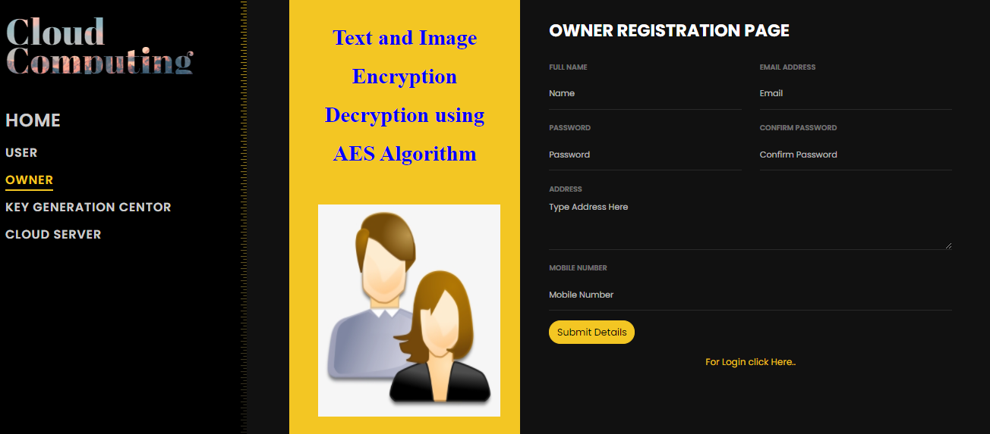

DATA OWNER LOGIN PAGE:

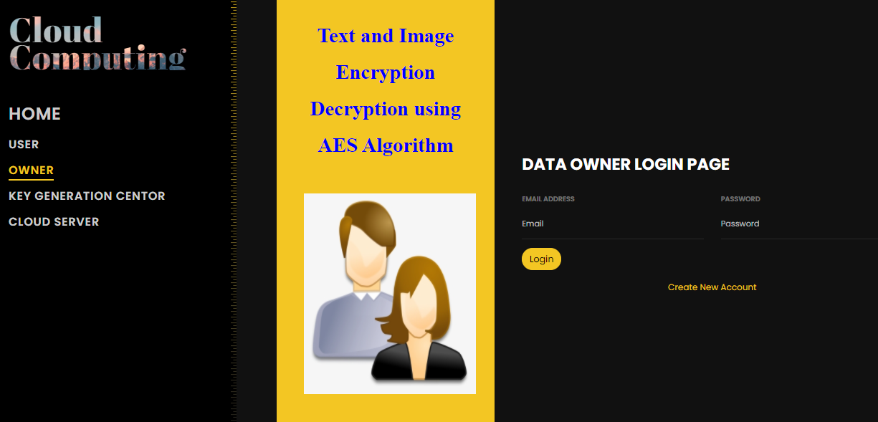

DATA OWNER HOMEPAGE:

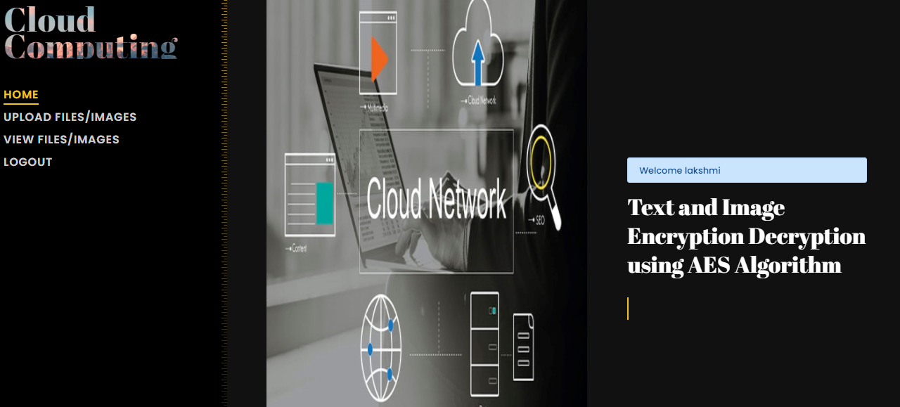

UPLOAD IMAGE/ TEXT FILES PAGE:

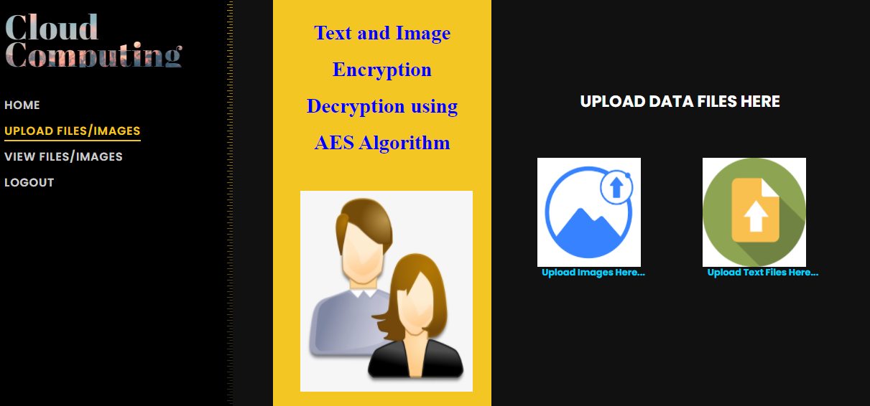

UPLOAD TEXT FILES:

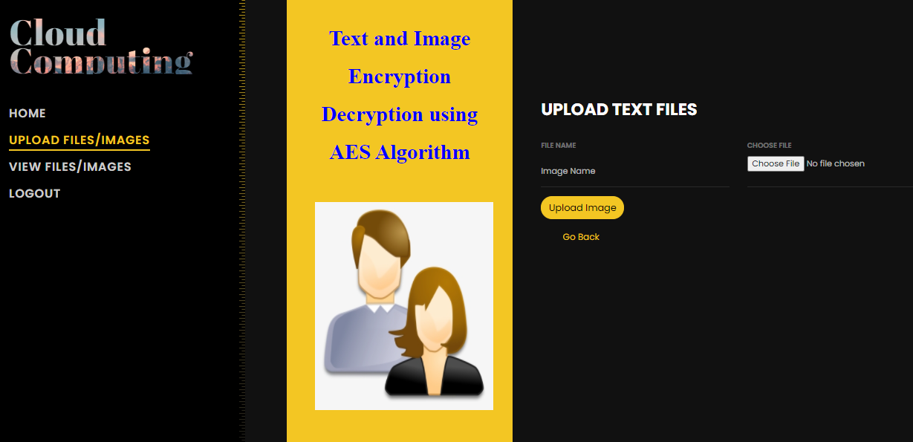

UPLOAD IMAGES FILES:

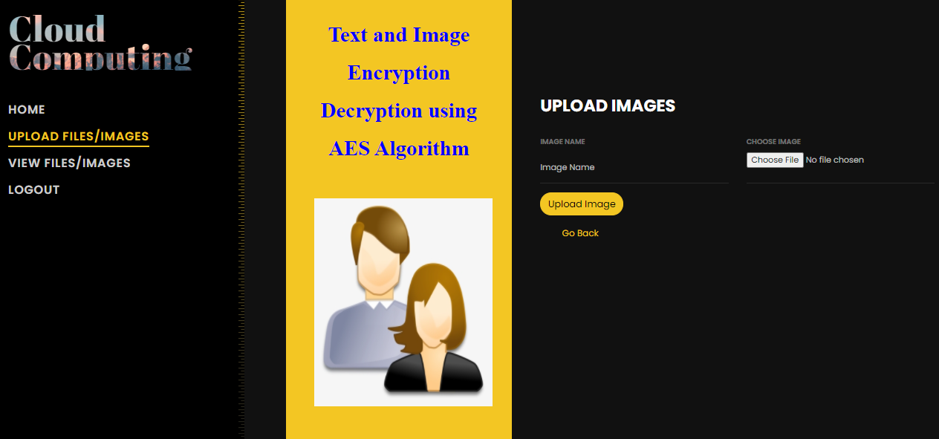

VIEW TEXT AND IMAGE FILES:

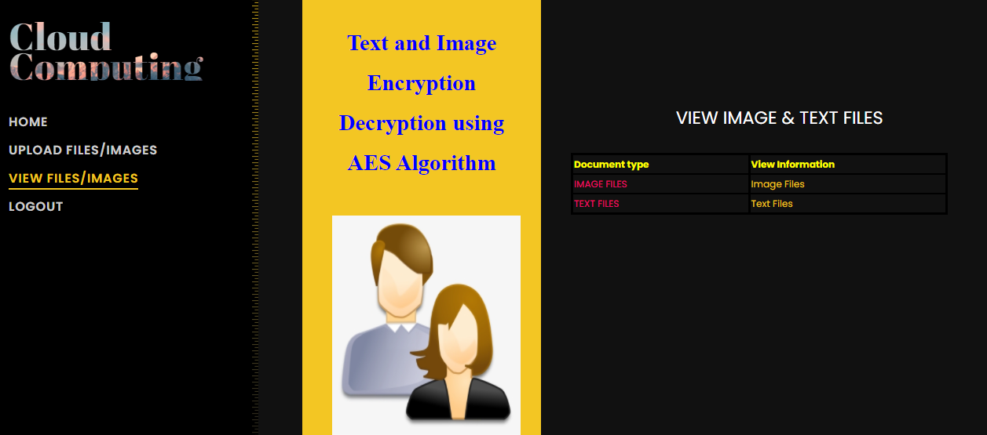

VIEW ONLY TEXT FILES:

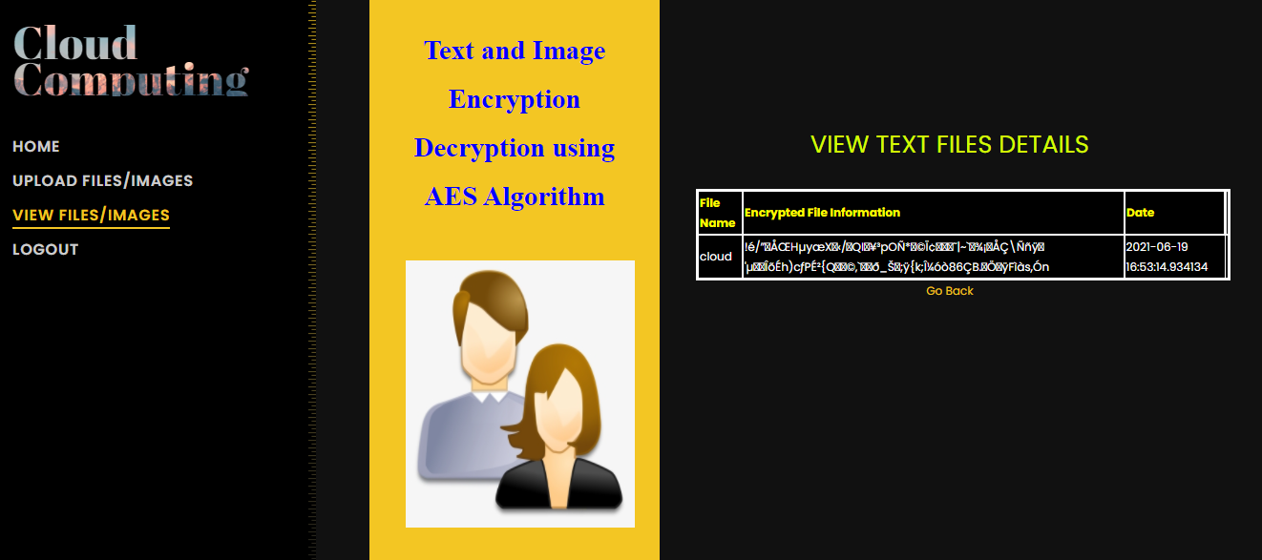

VIEW ONLY IMAGE DATA:

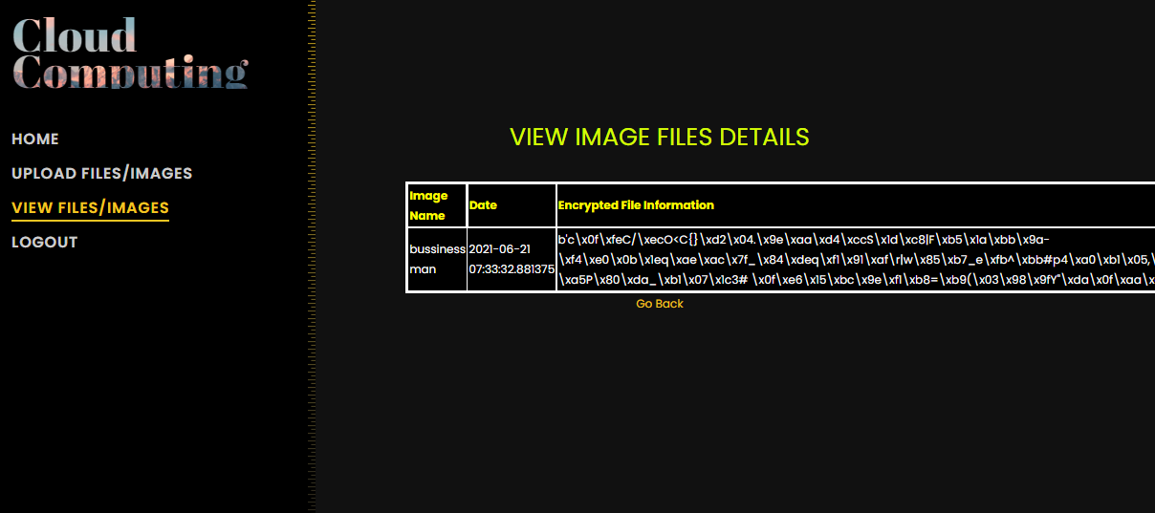

CLOUD SERVER LOGIN PAGE:

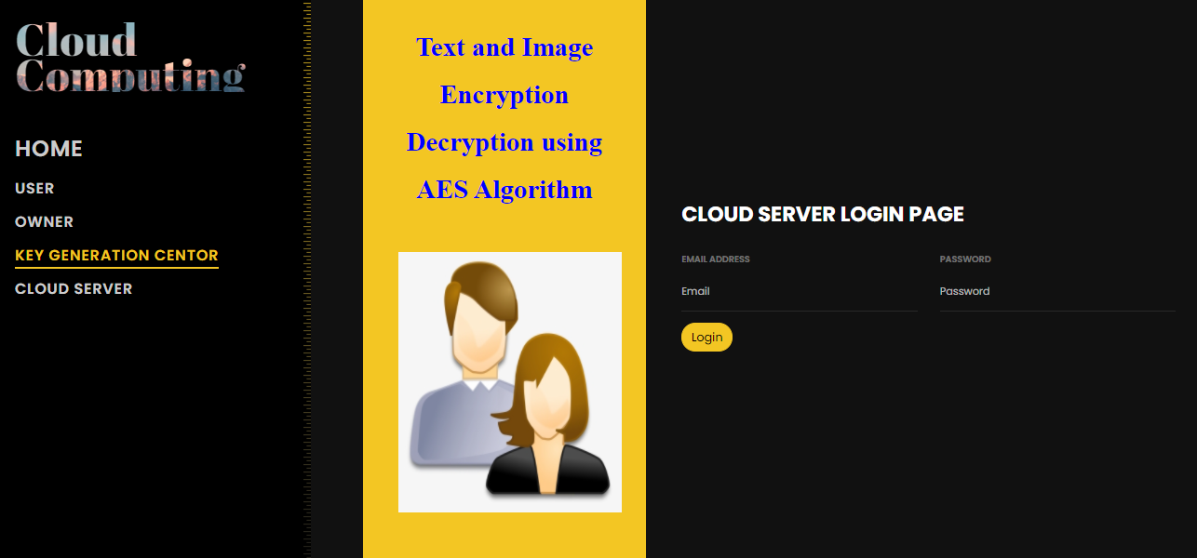

CLOUD SERVER HOME PAGE:

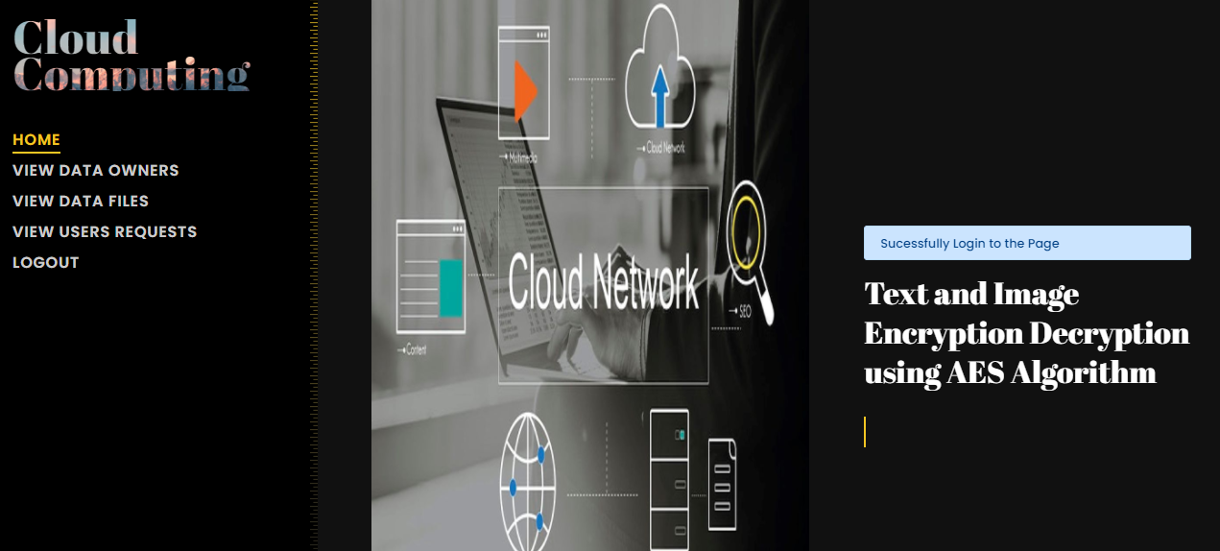

VIEW DATAOWNERS DETAILS:

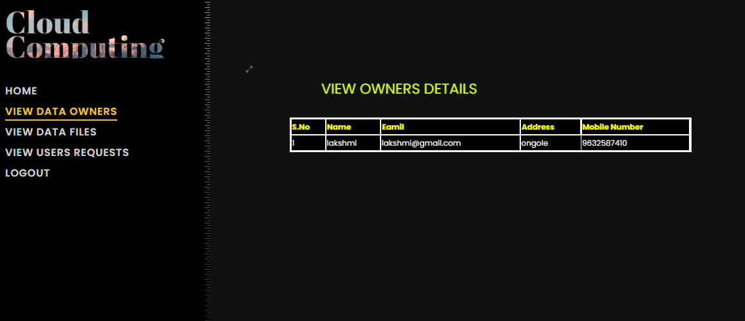

DATA FILES UPLOADED BY DATA OWNERS:

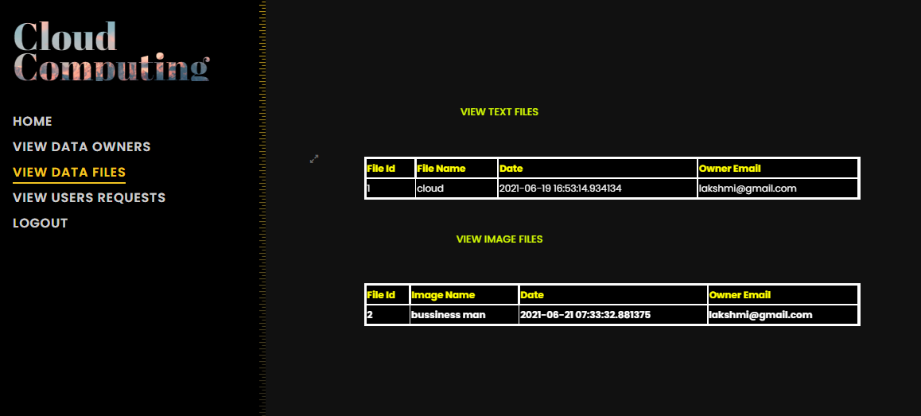

ACCEPT USERS REQUESTED FILES:

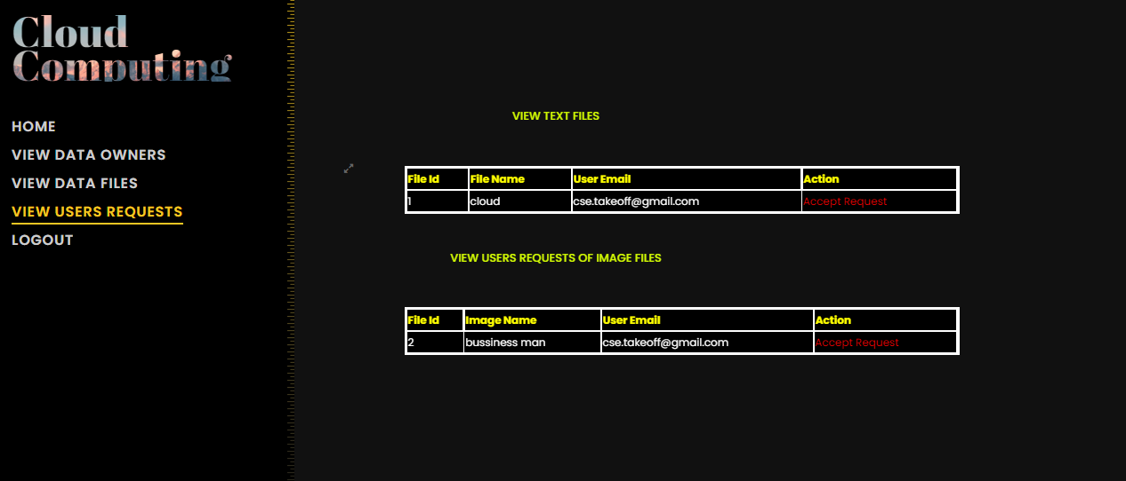

USER REGISTRATION PAGE:

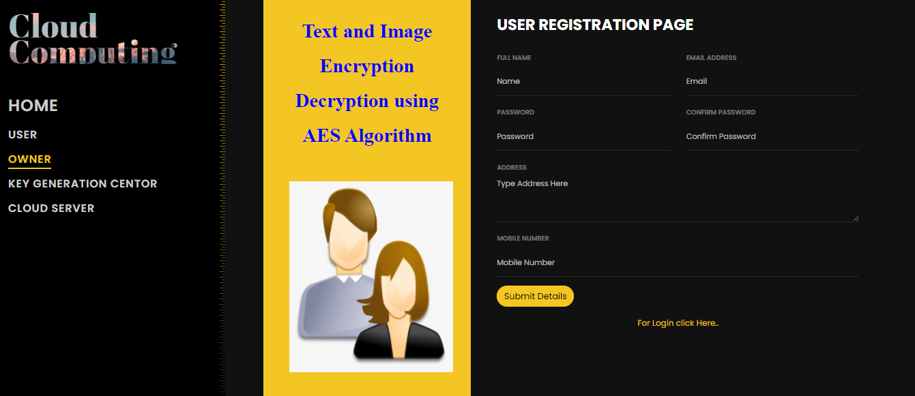

USER LOGIN PAGE:

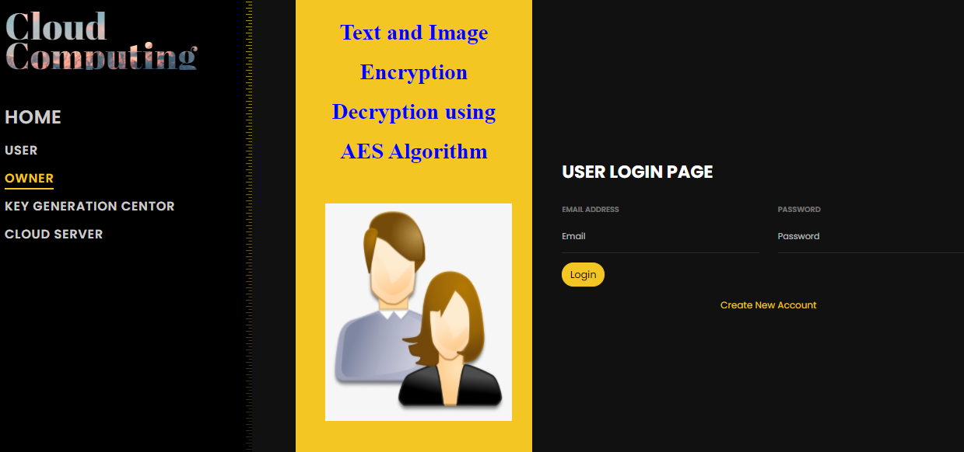

USER HOME PAGE:



SEARCH DATA FILES PAGE:

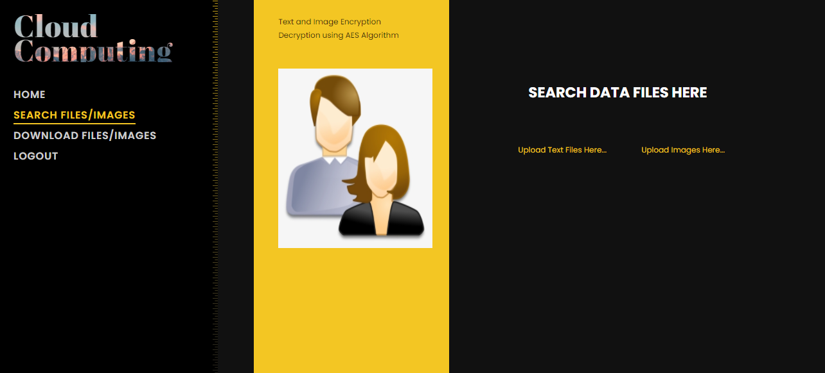

TEST FILES SEARCHING:

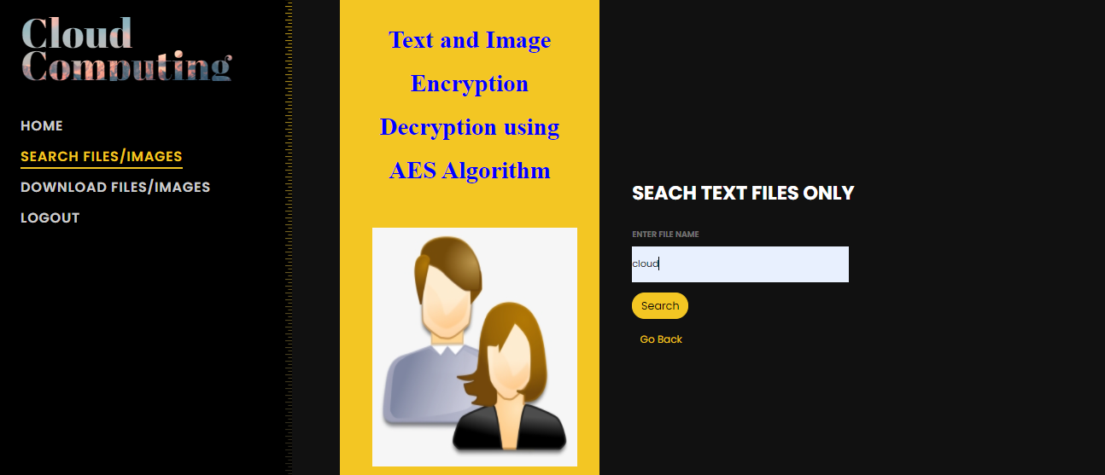

VIEW SEARCHING TECT FILE DATA:

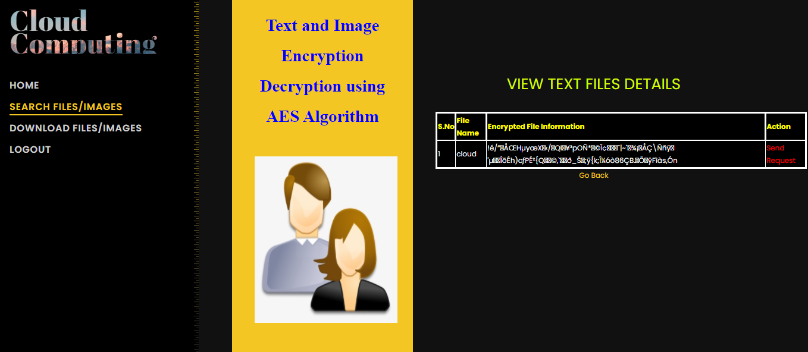

SEARCH AN IMAGE FILES:

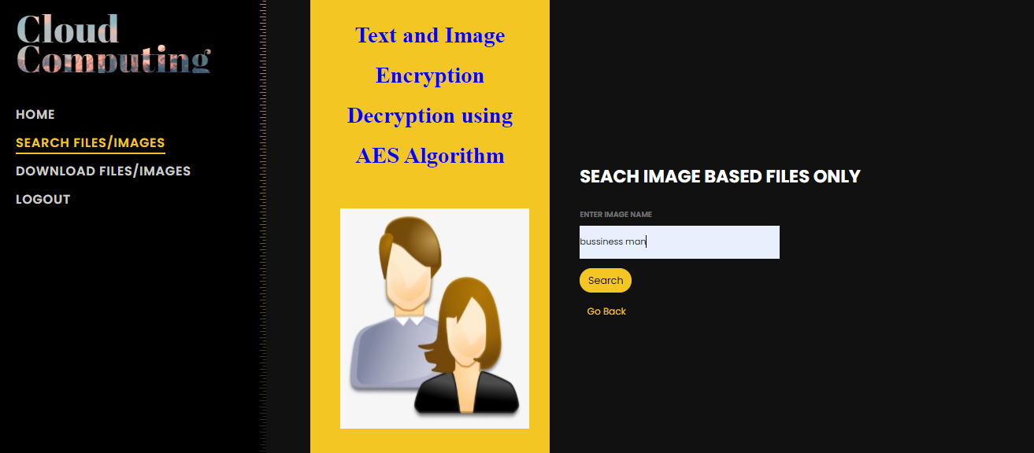

VIEW SEACHED IMAGE DETAILS:

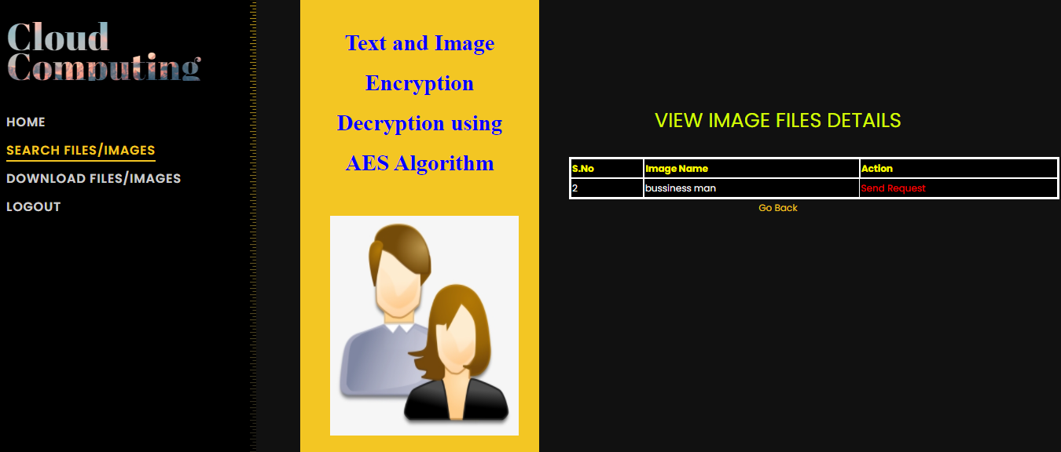

KGC LOGIN PAGE:

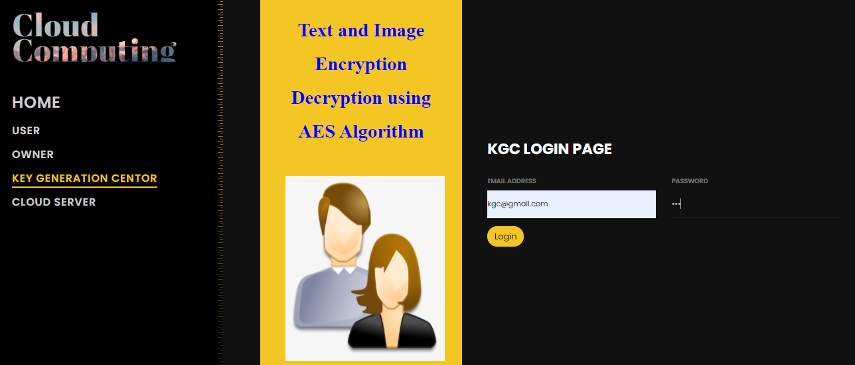

KGC HOME PAGE:

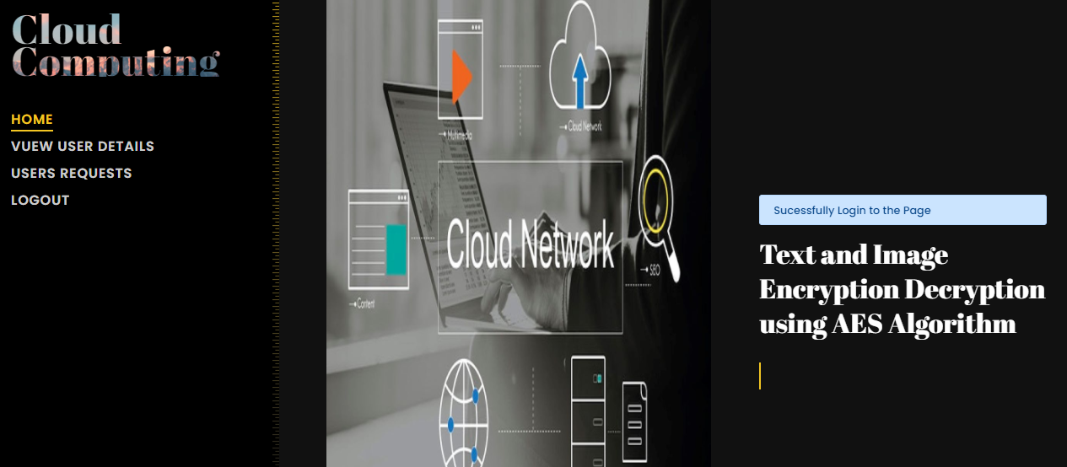

USERS REGISTRATION DETAILS:

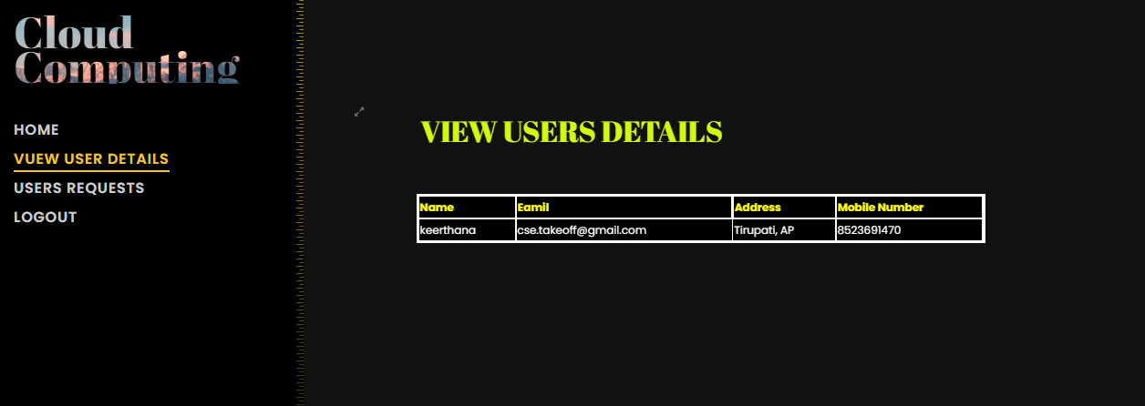

USER REQUESTED FILES:

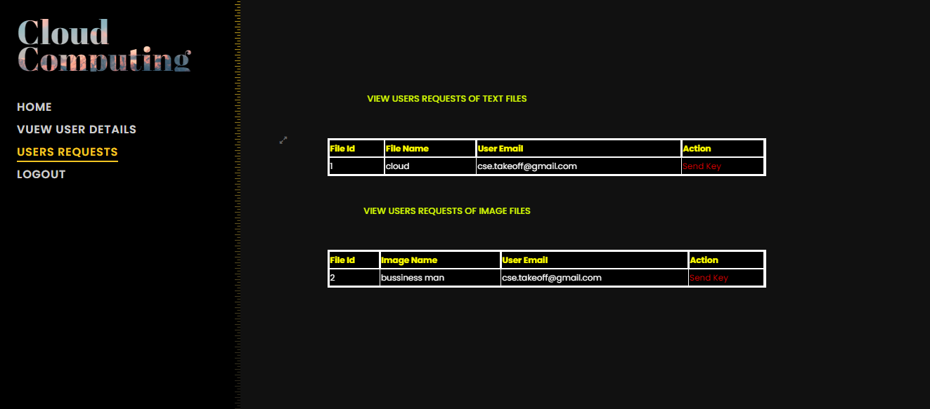

DOWNLOAD IMAGE AND TEXT FILES:

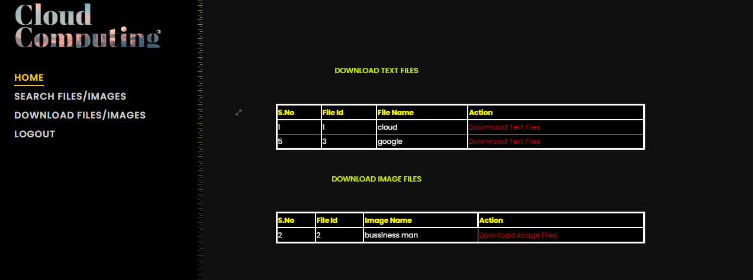

DECRYPT THEI IMAGE:

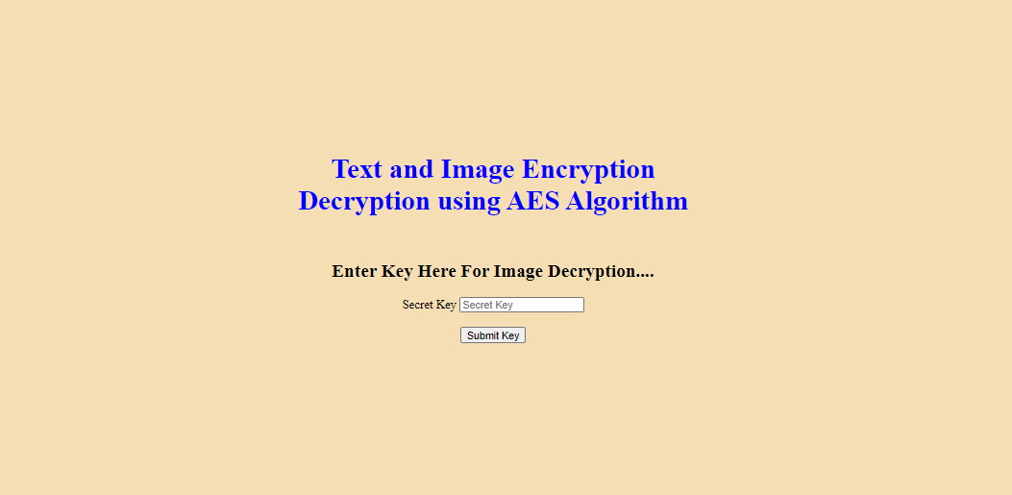

DECRYPTED IMAGE:

